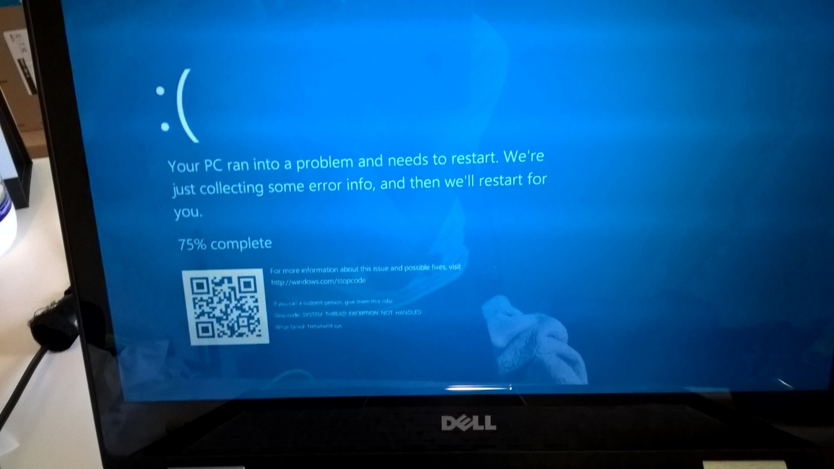

Happened near deadline, went through multiple cycles.

Also deleted some of my writing.

Must remember to update regularly.